Fact Sheet:
Public Support for Deposit Return Systems

Single-use bottles and cans are being used to sell an increasing variety of beverages from juices and bottled water to energy drinks and other non-carbonated beverages. Since their introduction to the market more than 40 years ago, there has been a significant debate over the most efficient way to collect these containers for high-quality recycling. While there are many who continue to argue that the solution to beverage container waste is municipal household curbside recycling programs, the last few years has seen unprecedented interest in deposit return initiatives, with several countries passing new and expanded deposit laws as a complement to their existing household collection models.

It’s difficult to pinpoint a single catalyst for this renewed interest, but the growing marine litter crisis has certainly played a part. According to the U.K.-based Marine Conservation Society’s Great British Beach Clean surveys, plastic drinks bottles, along with caps, lids, cans and glass bottles and other plastic on-the-go drink items consistently feature in the top ten of litter types strewn on U.K. beaches. Together, these items make up approximately 20% of all garbage found in MCS’s surveys spanning almost 25 years. If the problem remains unchecked, it is expected that the oceans may contain one tonne of plastic for every three tonnes of fish by 2025, and more plastics than fish (by weight) by 2050.

While there is a diverse array of policy approaches to the problem of marine debris, container deposit systems have proven to be one of the most effective. In recognition of this, an Australian senate committee report issued in April 2016 recommended that the government encourage its states and territories to implement container deposit schemes to address marine plastic pollution. The committee found that there was widespread public support for such schemes and that there was sufficient evidence to support the claim that the schemes reduce litter in the environment.

From North America to Australia and across Europe, deposit return legislation has historically enjoyed widespread public support. New laws receive much public fervour, and most respondents to public opinion polls support expansion of existing deposit laws. This fact sheet represents a compilation of over 60 public opinion polls gathered on a global scale from 2003-2021. The data focuses on public attitudes and opinions towards beverage container deposit legislation in 17 countries. For more details, see our ‘Table of Polling Studies’ available on our website.

Countries covered:
- Australia | - Ireland
- Austria | - France
- Belgium | - Romania
- Hungary | - Scotland
- Lithuania | - Wales
- Netherlands | - United Kingdom (UK)
- Spain | - United States of America (USA)
- Slovakia | - Canada

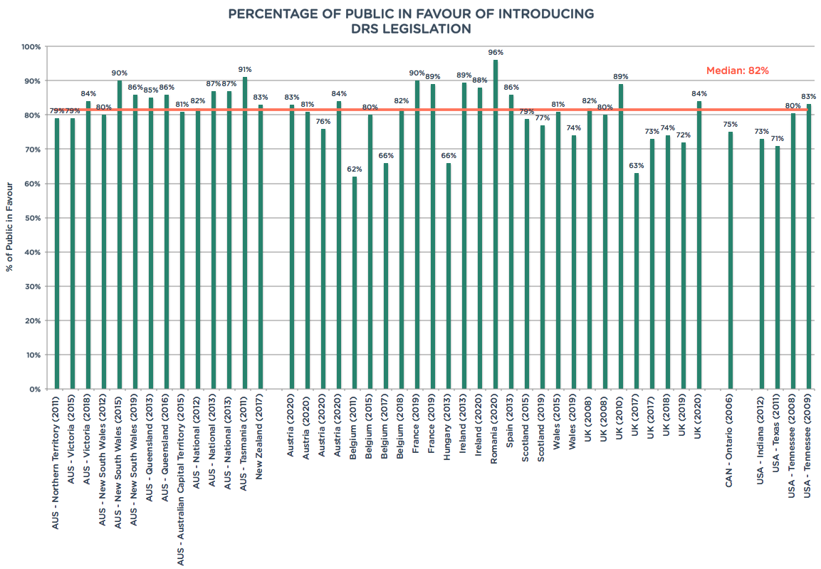

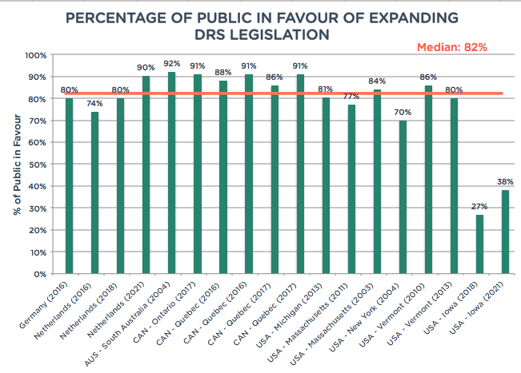

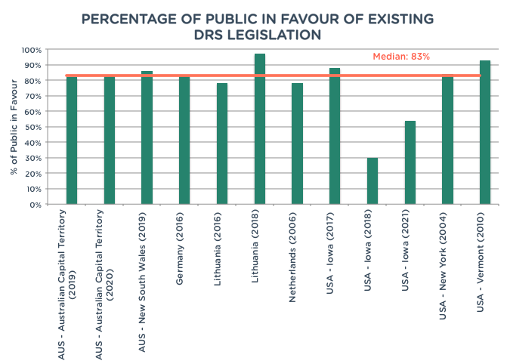

Reloop's vision is a world free of pollution, where an ambitious and integrated circular economy allows our precious resources to remain resources, so that people, businesses and nature can flourish. Our mission is to work with governments, industry and society to accelerate the global transition to a circular economy for all resources.

To learn more about Reloop and keep up-to-date with our latest work, follow us on social media or visit our website at www.reloopplatform.org

Endnotes

Harrington, R. 28 March 2018. “Deposit Refund Scheme announced for England.” <https://www.mcsuk.org/news/drs_england>
ibid.
World Economic Forum, Ellen MacArthur Foundation and McKinsey & Company, The New Plastics Economy — Rethinking the future of plastics (2016, http://www.ellenmacarthurfoundation.org/publications).
The Senate – Environment and Communications References Committee. April 2016. “Toxic tide: the threat of marine plastic pollution in Australia.” www.aph.gov.au/Parliamentary_Business/Committees/Senate/Environment_and_Communications/Marine_plastics/Report

